**LAB**

**NAME : Suganthan Kumaresan**

**REG NO : 192424105**

**COURSE : CSA1423-Compiler Design**

**EXP 3**

Develop a lexical Analyzer to test whether a given identifier is valid or not.

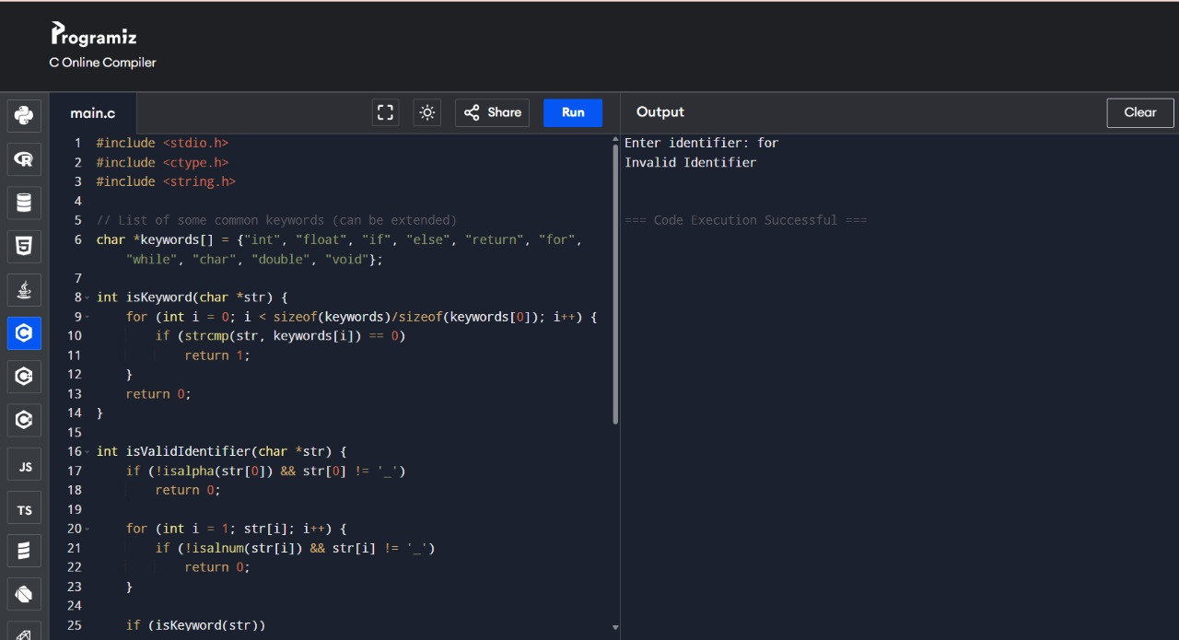

**EXP 4**

Implement a C program to eliminate left recursion.

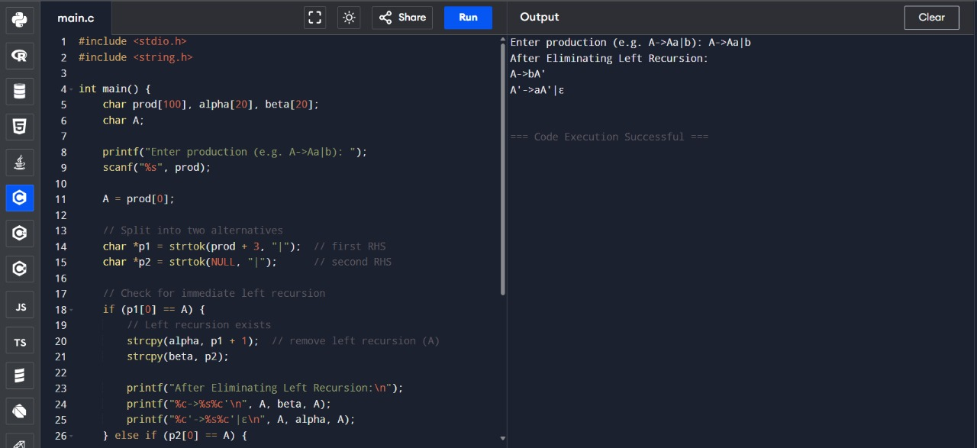

**EXP 5**

Implement a C program to eliminate left factoring.

